Comprehensive Review: Classification with Logistic Regression

Glossary of Terms
Term | Definition
Classification | A supervised learning task where the output is a discrete category/class (e.g., malignant vs. benign)
Regression | A supervised learning task where the output is a continuous numerical value (e.g., dosage in mg)
Logistic Regression | A classification algorithm that uses the sigmoid function to map predictions to probabilities between 0 and 1
Sigmoid Function | g(z)=11+e−zg(z) = \frac{1}{1 + e^{-z}} — an S-shaped curve that maps any real number to the range (0, 1)
Decision Boundary | The threshold surface that separates different classes in the feature space; can be linear or non-linear depending on features used
Polynomial Features | Engineered features like x2x^2, x1x2x_1x_2, etc., that enable non-linear decision boundaries
Loss Function | L(fw⃗,b(x⃗(i)),y(i))L(f_{\vec{w},b}(\vec{x}^{(i)}), y^{(i)}) — measures error for a single training example
Cost Function | J(w⃗,b)=1m∑i=1mL(…)J(\vec{w}, b) = \frac{1}{m}\sum_{i=1}^{m} L(\ldots) — the average loss across all training examples
Binary Cross-Entropy | The specific loss function used in logistic regression: −ylog⁡(f)−(1−y)log⁡(1−f)-y\log(f) - (1-y)\log(1-f)
Gradient Descent | An optimization algorithm that iteratively updates parameters by moving in the direction of steepest descent of the cost function
Learning Rate (αα) | Controls the step size of each gradient descent update
Overfitting (High Variance) | When a model fits training data too closely, capturing noise rather than general patterns
Underfitting (High Bias) | When a model is too simple to capture the underlying structure of the data
Regularization | A technique that adds a penalty term to the cost function to discourage large parameter values
Regularization Parameter (λλ) | Controls the strength of the regularization penalty; higher λλ → smaller weights
L2 Regularization (Ridge) | Penalizes the sum of squared weights: λ2m∑wj2\frac{\lambda}{2m}\sum w_j^2
Nominal Data | Categorical data with no inherent order (e.g., car color: black, white, blue)
Ordinal Data | Categorical data with a meaningful order/hierarchy (e.g., condition: Excellent > New > Good > Fair)
Label Encoding | Converts categorical text to integers; can introduce false ordinal relationships for nominal data
One-Hot Encoding | Creates binary dummy variables (0/1) for each category; avoids ordinal assumptions
Dummy Variable | A binary indicator variable (1 if the category is present, 0 otherwise)
Sparse Matrix | A matrix with many zeros; a downside of one-hot encoding with many categories



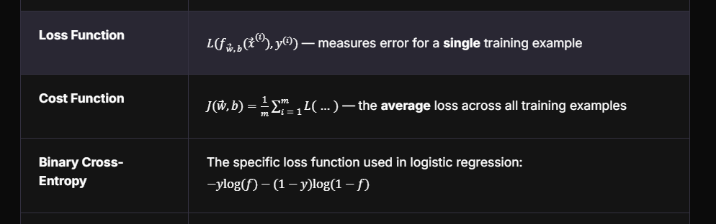


10 Key Takeaways

1. Classification ≠ Regression
The first step in any ML problem is identifying the task type. If the output is a category (cat/not cat, malignant/benign), it's classification. If the output is a continuous number (dosage, price), it's regression.

2. The Sigmoid Function Is the Heart of Logistic Regression
g(z)=11+e−zg(z) = \frac{1}{1 + e^{-z}} transforms any real-valued input into a probability between 0 and 1. Large positive z→1z → 1, large negative z→0z → 0, and z=0→0.5z = 0 → 0.5. This is what enables logistic regression to output probabilities.
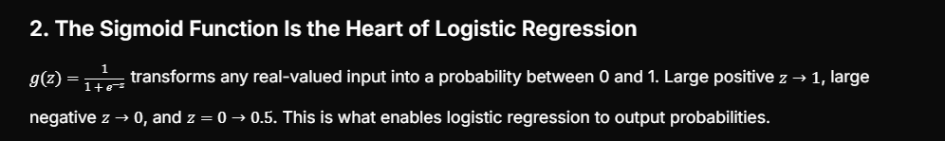

3. 0.5 Is the Natural Decision Threshold
By default, if g(z)≥0.5g(z) \geq 0.5, predict class 1; otherwise, predict class 0. This threshold can be adjusted based on whether you prioritize precision or recall, but 0.5 is the standard starting point.

4. Polynomial Features Unlock Non-Linear Boundaries
Logistic regression is always linear in its features, but if those features are polynomial transformations of the original inputs (x12x_1^2, x1x2x_1x_2, etc.), the decision boundary in the original input space becomes non-linear (curves, circles, ellipses).
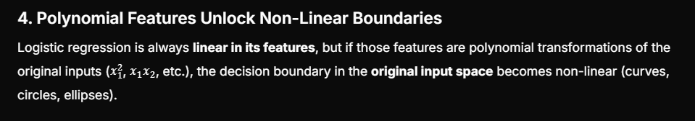

5. Loss vs. Cost — Know the Difference
Loss = error on one example. Cost = average loss across all examples. This distinction matters when communicating about model performance and understanding the optimization objective.

6. Binary Cross-Entropy Is Elegant by Design
The single formula −ylog⁡(f)−(1−y)log⁡(1−f)-y\log(f) - (1-y)\log(1-f) handles both classes automatically. When y=1y=1, only the first term matters. When y=0y=0, only the second term matters. No conditional logic needed.


7. Same Gradient Descent Recipe, Different Prediction Function
The update rules for linear and logistic regression look identical on the surface. The critical difference is that fw⃗,b(x⃗)f_{\vec{w},b}(\vec{x}) is a linear function in linear regression but a sigmoid in logistic regression. This changes the entire optimization landscape.

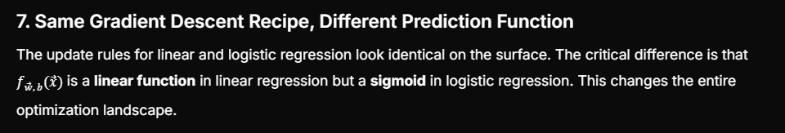

8. Know Your Data Types Before Encoding
Ordinal data (condition ratings) has a natural hierarchy — use ordinal encoding. Nominal data (colors, car brands) has no order — label encoding introduces false hierarchies, so use one-hot encoding instead.

9. Overfitting Has Clear Symptoms and Solutions
A wiggly, overly complex decision boundary that wraps around individual data points is a hallmark of high variance. The fixes: collect more data, reduce features, or apply regularization.

10. Regularization Shrinks Weights Toward Zero
Increasing λλ penalizes large weights more heavily, forcing the model toward simplicity. Too little λλ → overfitting. Too much λλ → underfitting. Finding the right λλ is a key hyperparameter tuning challenge.

Target Student Profile
Based on the question types, difficulty progression, and skills assessed, the course targets the following profile:

Aspiring ML Practitioner — Foundations Level
Dimension | Assessment Evidence
Technical Background | Basic Python and pandas familiarity assumed (coding questions use pd.read_csv, .value_counts(), .astype() without explanation)
Math Comfort Level | Moderate — students need to read formulas, substitute values, and reason about limits (z→+∞z \to +\infty), but are not asked to derive gradients from scratch
Conceptual Focus | Strong emphasis on intuition over computation — questions test "what happens when…" rather than "calculate the exact value of…"
Visual Literacy | Students must interpret scatter plots, decision boundaries, and sigmoid graphs to diagnose model behavior
Practical Mindset | Coding questions focus on real-world data prep (encoding categorical variables) rather than algorithm implementation from scratch
Diagnostic Thinking | Multiple questions assess the ability to look at a model's output and determine what's wrong (overfit vs. underfit) and what to do about it
Course Level | Introductory — likely a first course in ML (similar to Andrew Ng's Machine Learning Specialization), designed to build intuition before diving into deep mathematics

The ideal student is someone who:
- Can write basic Python and use pandas
- Is comfortable reading mathematical notation but doesn't need to prove theorems
- Wants to understand why algorithms work, not just how to call model.fit()
- Is building toward more advanced topics (neural networks, deep learning)

Important Concepts to Study in More Depth

🔴 High Priority — Core Foundations
Concept | Why It Matters | Recommended Deep Dive
Maximum Likelihood Estimation (MLE) | Binary cross-entropy isn't arbitrary — it's derived from MLE. Understanding why this specific loss function is used gives deep insight. | Study how maximizing likelihood is equivalent to minimizing negative log-likelihood, and how this produces the cross-entropy formula
Derivation of Gradient Descent for Logistic Regression | The course shows the update rule but doesn't derive it. Understanding the calculus (chain rule through the sigmoid) builds real understanding. | Work through the partial derivatives ∂J∂wj\frac{\partial J}{\partial w_j} and ∂J∂b\frac{\partial J}{\partial b} using chain rule through g(z)g(z)
L1 vs. L2 Regularization | The course covers L2 (Ridge). L1 (Lasso) behaves differently — it produces sparse weights (some become exactly zero), which is a form of automatic feature selection. | Compare the geometry of L1 (diamond constraint) vs. L2 (circle constraint) and their effects on the solution
Bias-Variance Tradeoff (Formal) | The course introduces this intuitively. A formal treatment helps understand why more data helps variance but not bias, and how model complexity affects both. | Study learning curves (training error vs. validation error as a function of dataset size)

🟡 Medium Priority — Practical Skills
Concept | Why It Matters | Recommended Deep Dive
Choosing the Right Encoding Strategy | The course covers ordinal, label, and one-hot encoding, but doesn't discuss when each fails or alternatives like target/frequency encoding for high-cardinality features. | Explore target encoding, frequency encoding, and embedding layers for categorical variables with many categories
Feature Scaling & Standardization | Not covered in these quizzes but essential for regularization to work properly — without scaling, regularization unfairly penalizes features with larger numeric ranges. | Study StandardScaler, MinMaxScaler, and why regularization assumes features are on comparable scales
Hyperparameter Tuning for λλ | The course explains what λλ does but not how to choose it. | Study grid search, random search, and cross-validation for selecting optimal λλ
Multiclass Classification | All questions involve binary classification. Real-world problems often have 3+ classes. | Study softmax regression (multinomial logistic regression), one-vs-rest, and one-vs-one strategies
Evaluation Metrics Beyond Accuracy | The course doesn't cover how to evaluate classification models. Accuracy alone can be misleading (especially with imbalanced classes). | Study precision, recall, F1-score, ROC-AUC, confusion matrices, and when each metric is appropriate

🟢 Lower Priority — Advanced Extensions
Concept | Why It Matters | Recommended Deep Dive
Convergence of Gradient Descent | Understanding when and why gradient descent converges (convexity of logistic regression cost function, role of learning rate) | Study convex optimization basics, and why logistic regression's cost function is convex
Regularization in Neural Networks | The concepts here (L2 regularization, overfitting) extend directly to deep learning, but with additional techniques like dropout and batch normalization | Study dropout, early stopping, data augmentation, and batch normalization as regularization methods in neural networks
Probabilistic Interpretation | Logistic regression outputs probabilities — but are they calibrated? A model can classify well but have poorly calibrated probabilities. | Study Platt scaling, isotonic regression, and calibration plots

Recommended Study Path
Current Level (Course Completion) │ ▼┌─────────────────────────┐│ 1. MLE & Cross-Entropy │ ← Understand WHY the loss function exists│ Derivation │└───────────┬─────────────┘ ▼┌─────────────────────────┐│ 2. Gradient Derivation │ ← Understand HOW optimization works│ (Chain Rule) │└───────────┬─────────────┘ ▼┌─────────────────────────┐│ 3. Bias-Variance │ ← Understand WHEN models fail│ Formal Treatment │└───────────┬─────────────┘ ▼┌─────────────────────────┐│ 4. Evaluation Metrics │ ← Understand HOW to measure success│ & Calibration │└───────────┬─────────────┘ ▼┌─────────────────────────┐│ 5. Multiclass & │ ← Expand to REAL-WORLD scenarios│ Advanced Encoding │└─────────────────────────┘
This study path takes you from intuition (where the course leaves you) to mastery (where you can confidently build, debug, and optimize logistic regression models in practice). Good luck! 🎯

Checklists for Logistic Regression & Categorical Encoding

Why a Methodical Approach Matters
Machine learning is deceptive — a model can "run" without errors yet be fundamentally wrong. Unlike traditional software where bugs crash visibly, ML bugs manifest as silent failures: a model trains, produces predictions, and looks like it works, but is actually overfitting, leaking data, or encoding categories incorrectly. A procedural approach matters because:
Risk | What Happens Without a Checklist | Consequence
Task misidentification | Applying regression to a classification problem | Wrong algorithm, meaningless outputs
Encoding errors | Label-encoding nominal data | Model learns false hierarchies (white cars "worth" 6× blue cars)
Overfitting blindness | No diagnosis of model complexity | Model performs great on training, fails in production
Threshold negligence | Defaulting to 0.5 without thought | Wrong tradeoffs between false positives and false negatives
Regularization misuse | Applying L2 without feature scaling | Penalty unfairly targets large-range features
Evaluation gaps | Reporting only accuracy | Hidden failures on minority classes
A checklist transforms implicit knowledge into explicit, repeatable steps — reducing cognitive load and catching errors before they propagate downstream.

Top 5 Checklists

Checklist 1: Problem Definition & Task Identification

# | Check Item | Why It Matters | Phase
1 | Identify the output type: Is the target a category (classification) or a continuous number (regression)? | Determines algorithm family — logistic regression for categories, linear regression for continuous values | Learning
2 | If classification, identify the number of classes: Binary (2) or multiclass (3+)? | Binary uses sigmoid; multiclass requires softmax or one-vs-rest strategy | Labs
3 | Define what each class means in the real world: What does y=1y=1 represent? What does y=0y=0 represent? | Prevents confusion when interpreting probabilities and setting thresholds | Production
4 | Assess class balance: Are classes roughly equal, or is one rare? | Imbalanced data requires special handling (resampling, weighted loss, different metrics) | Production
5 | Clarify the cost of errors: Is a false positive worse than a false negative, or vice versa? | Directly informs threshold selection — medical diagnosis (false negative = disaster) vs. spam filter (false positive = annoyance) | Production
Start with the question, not the algorithm info
Many ML failures originate from jumping straight to modeling without clearly defining what the model is supposed to predict and why. A well-defined problem narrows algorithm choice, encoding strategy, evaluation metric, and deployment threshold — all downstream decisions cascade from this initial step.
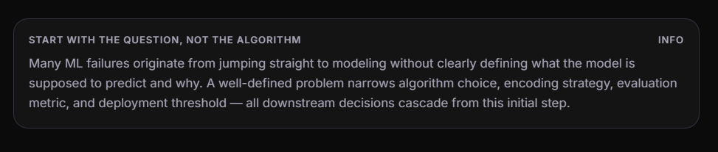

Checklist 2: Data Understanding & Encoding

# | Check Item | Why It Matters | Phase
1 | Inspect dtypes for every feature: Are numerical features stored as numbers? Are text features object? | Catches data loaded as strings that look numeric but aren't processable by models | Learning
2 | Classify each categorical feature as nominal or ordinal: Does this feature have a natural order? | Ordinal → ordinal encoding preserves hierarchy; Nominal → one-hot encoding avoids false ordering | Labs
3 | For ordinal features, define the hierarchy explicitly: Map the order (e.g., Excellent=5, New=4, …, Fair=1) | Incorrect ordering injects wrong information into the model — the order must reflect domain knowledge | Labs
4 | For nominal features, check cardinality: How many unique categories exist? | High cardinality (>15-20) with one-hot encoding creates sparse matrices and can degrade model performance — consider grouping rare categories or alternative encoding | Production
5 | Handle NaN values before encoding: Both OrdinalEncoder and LabelEncoder fail on missing values | Encoding must happen after imputation; the choice of imputation strategy (mode, "Unknown" category) affects model behavior | Production
6 | Verify encoding results: Compare value_counts() before and after transformation to confirm correctness | Sanity check — ensures mappings are applied as intended and no categories were silently dropped | Labs
7 | Join encoded features back to the dataframe and drop the original column: Avoid redundancy | Keeping both the original text column and encoded version confuses the model with duplicate information | Labs
8 | Document the encoding mapping: Save the dictionary or encoder object | Reproducibility — in production, new incoming data must be encoded identically using the same mapping | Production
Encoding is where domain knowledge meets data engineering warning
The choice between ordinal, label, and one-hot encoding is not purely technical — it requires understanding whether the data has inherent order (a domain question) and how the model will interpret the resulting numbers. Wrong encoding choices silently corrupt the model's understanding of the data.
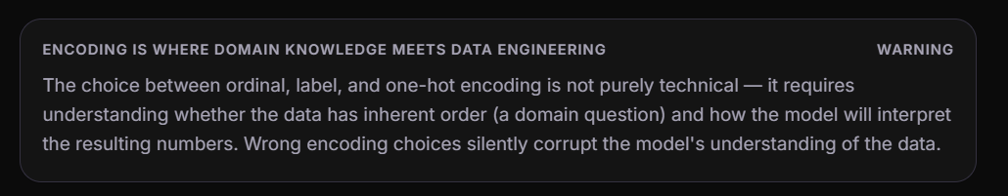

Checklist 3: Model Building & Training

# | Check Item | Why It Matters | Phase
1 | Confirm the prediction function: Is fw⃗,b(x⃗)=11+e−(w⃗⋅x⃗+b)f_{\vec{w},b}(\vec{x}) = \frac{1}{1+e^{-(\vec{w}\cdot\vec{x}+b)}} (sigmoid)? | Using a linear function instead of sigmoid means the model isn't performing classification — it's doing regression | Learning
2 | Verify the loss function: Is binary cross-entropy being used? L=−ylog⁡(f)−(1−y)log⁡(1−f)L = -y\log(f) - (1-y)\log(1-f) | MSE is inappropriate for classification — it's non-convex with sigmoid, causing gradient descent to get stuck | Learning
3 | Check the decision threshold: Is 0.5 appropriate, or should it be adjusted? | Default 0.5 assumes equal cost of errors; real-world applications often need custom thresholds | Production
4 | Consider polynomial features if the boundary should be non-linear: Are there interaction terms (x1x2x_1 x_2), quadratic terms (x2x^2)? | Linear boundaries can't separate certain class distributions; polynomial features enable curves, circles, etc. | Labs
5 | Scale features before applying regularization: Are all features on comparable scales? | L2 regularization penalizes wj2w_j^2 equally — unscaled features mean large-range features get unfairly penalized (or small-range features escape penalty) | Production
6 | Set an appropriate learning rate (αα): Is the cost decreasing smoothly, oscillating, or plateauing? | Too high → divergence; too low → painfully slow convergence; monitor cost curve to tune | Labs
7 | Monitor the cost function during training: Plot J(w⃗,b)J(\vec{w},b) vs. iterations | A decreasing cost confirms learning; a flat cost may indicate converged or stuck; an increasing cost means divergence | Labs

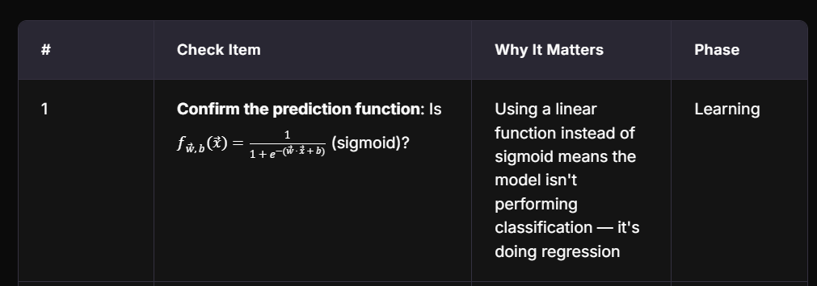
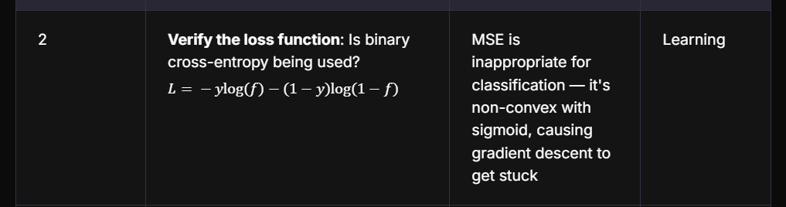
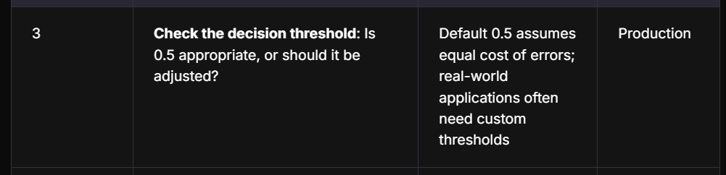

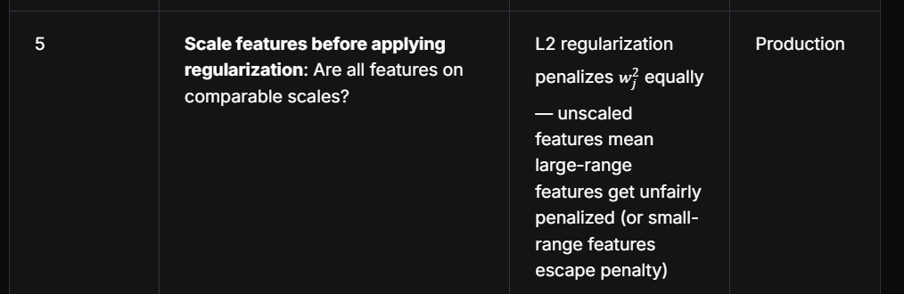
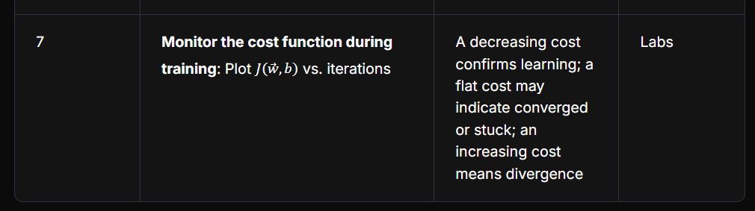

Checklist 4: Model Diagnosis & Regularization

# | Check Item | Why It Matters | Phase
1 | Plot the decision boundary (when feasible with 2D data): Is it smooth or wiggly? | Visual diagnosis — a wiggly boundary wrapping individual points signals overfitting; a too-simple boundary signals underfitting | Learning
2 | Compare training error vs. validation/test error: Is there a large gap? | Large gap (low train error, high test error) = high variance (overfit); high train error = high bias (underfit) | Labs
3 | Diagnose: high bias or high variance? | Determines the fix — overfitting needs regularization/more data/fewer features; underfitting needs more features/higher complexity | Learning
4 | If overfitting, apply at least one remedy: Collect more data? Reduce features? Apply regularization? | These are the three validated approaches — removing data makes overfitting worse, not better | Labs
5 | If using regularization, tune λλ: Start with small values and increase — does model performance improve then degrade? | Too small λλ → no effect (still overfit); too large λλ → weights collapse to zero (underfit); optimal λλ is in between | Production
6 | Check parameter magnitudes after training: Are any wjw_j disproportionately large? | Large weights on specific features can indicate overreliance on noise patterns; regularization should bring them into line | Production
7 | Verify that regularization reduces weight sizes as λλ increases: Sanity-check the mechanism | Confirms the regularization term is correctly implemented and functioning as expected | Labs
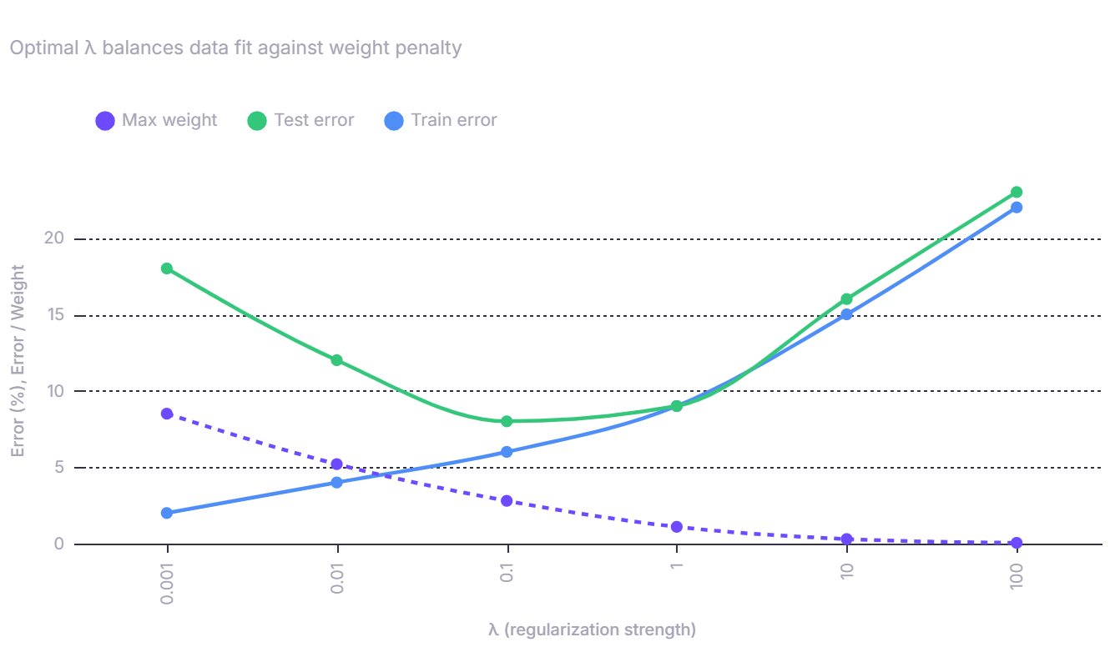
The U-shaped test error curve is the signature of regularization info
As λ increases from zero, test error first decreases (overfitting is reduced), reaches a minimum (optimal regularization), then increases again (model becomes too simple / underfits). Train error monotonically increases because the model fits training data less aggressively. The optimal λ sits at the bottom of the test error U-curve.
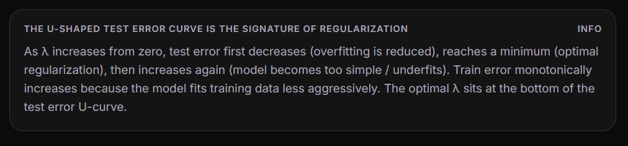

Checklist 5: Evaluation & Deployment Readiness

# | Check Item | Why It Matters | Phase
1 | Evaluate on held-out test data (never seen during training or validation) | Training accuracy is meaningless for assessing generalization — the model has seen that data | Labs
2 | Go beyond accuracy: Compute precision, recall, F1-score, and confusion matrix | Accuracy hides class-specific failures — 95% accuracy on imbalanced data where 95% is one class means the model learned nothing | Production
3 | If the model outputs probabilities, check calibration: Do predicted probabilities match observed frequencies? | A model saying "80% chance of cancer" should be correct ~80% of the time — uncalibrated probabilities lead to wrong decisions even with good classification | Production
4 | Test the model on edge cases: What happens with extreme inputs, missing features, or unseen categories? | Production data will inevitably contain values not in training — the model must fail gracefully, not crash or produce nonsense | Production
5 | Persist the full pipeline: Not just model weights, but the encoder mappings, scaler parameters, and feature list | New data in production must pass through identical preprocessing — a mismatch between training and serving pipelines is a top cause of production ML failures | Production
6 | Set up monitoring: Track prediction distribution drift, input feature distributions, and model performance over time | Models degrade as real-world data shifts; without monitoring, a once-good model silently degrades | Production
7 | Document the decision threshold rationale: Why 0.5? Or why 0.3? Or why 0.7? | The threshold encodes business logic — it must be justified, documented, and revisited as conditions change | Production
8 | Create a rollback plan: Can you revert to a previous model version if the new one underperforms? | Production deployments can fail; having version control for models enables quick recovery | Production

Summary: The Full Workflow
PROBLEM DEFINITION │ → Classification or regression? │ → Binary or multiclass? │ → Cost of false positives vs. false negatives? ▼DATA UNDERSTANDING & ENCODING │ → Inspect dtypes │ → Classify features: nominal vs. ordinal │ → Apply correct encoding strategy │ → Handle NaN values │ → Verify transformations │ → Document mappings ▼MODEL BUILDING & TRAINING │ → Confirm sigmoid prediction function │ → Use binary cross-entropy loss │ → Scale features (especially if regularizing) │ → Set learning rate │ → Monitor cost curve │ → Consider polynomial features if needed ▼MODEL DIAGNOSIS & REGULARIZATION │ → Visualize decision boundary │ → Compare train vs. test error │ → Diagnose: high bias or high variance? │ → Apply remedies (more data, fewer features, regularization) │ → Tune λ ▼EVALUATION & DEPLOYMENT → Evaluate on held-out test set → Compute precision, recall, F1, confusion matrix → Check probability calibration → Test edge cases → Persist full pipeline (encoders, scalers, model) → Set up monitoring → Document threshold rationale → Create rollback plan
Checklists
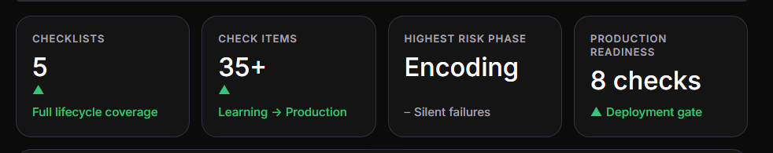
The discipline of checklists
Each checklist corresponds to a phase where silent failures are most likely: misidentifying the task (Checklist 1), encoding data incorrectly (Checklist 2), training with wrong loss functions or unscaled features (Checklist 3), shipping an overfit model without diagnosis (Checklist 4), and deploying without evaluation rigor or monitoring (Checklist 5). The procedural approach matters because ML errors compound — a wrong encoding feeds into a wrong model, which feeds into wrong predictions, which feed into wrong business decisions. Catching errors early at each gate prevents downstream propagation.
